**Assignment 3: 3D Scene Editor**

**Buttons Mapping**

**Insertion i**

**1 -add cube**

**2 -add bunny**

**3 -add bumpy cube**

**Deletion**

**p - delete selected**

**Object Control o**

**click mouse - select**

**move mouse -translate**

**h - rotate clockwise**

**j - rotate counterclockwise**

**k - scale up**

**l - scale down**

**shading**

**r - wireframe**

**t - flat shading**

**y - phong shading**

**camera control**

**d - move camera right**

**a - move camera left**

**w - move camera up**

**s - move camera down**

**e - move camera in**

**z - move camera out**

**z - orthographic projection**

**x - perspective projection**

**v - camera reset**

**c - camera control spherical**

**g - svg**

**Scene Editor**

**Insertion Mode**

**1 is pressed**

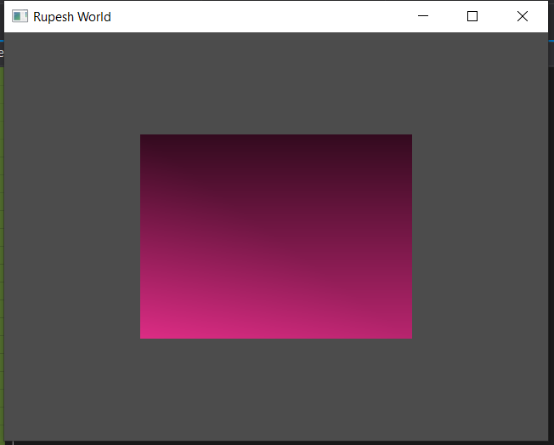

**O is click – (Object Control Mode) and cube is selected**

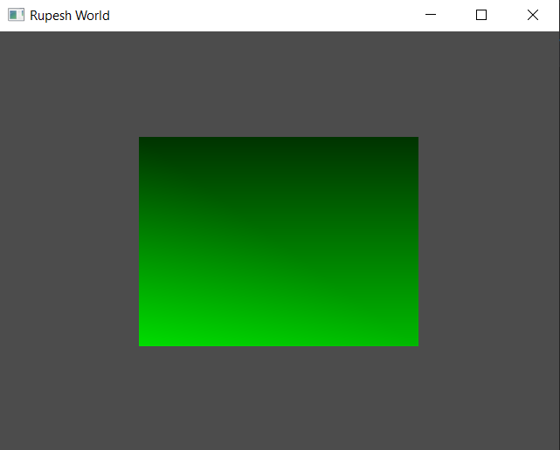

**Cube moved**

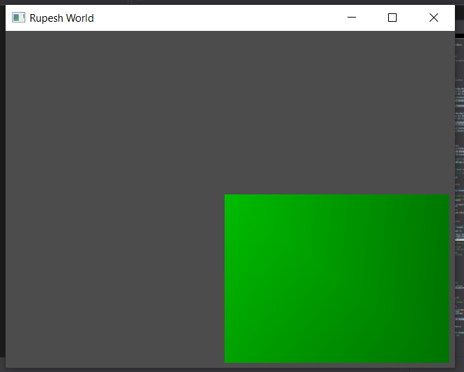

**I is pressed insertion mode and 2 is pressed and bunny is created**

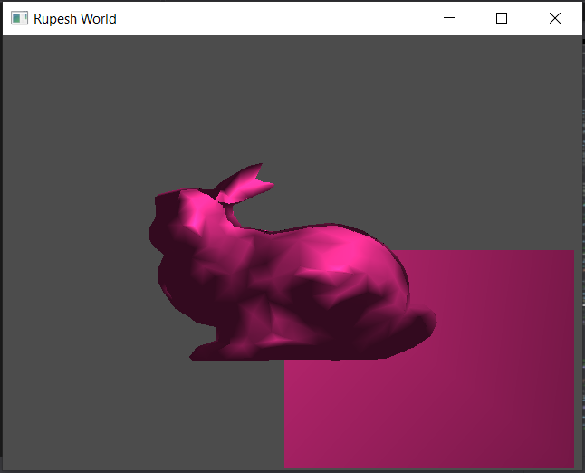

**O press, bunny selected and moved**

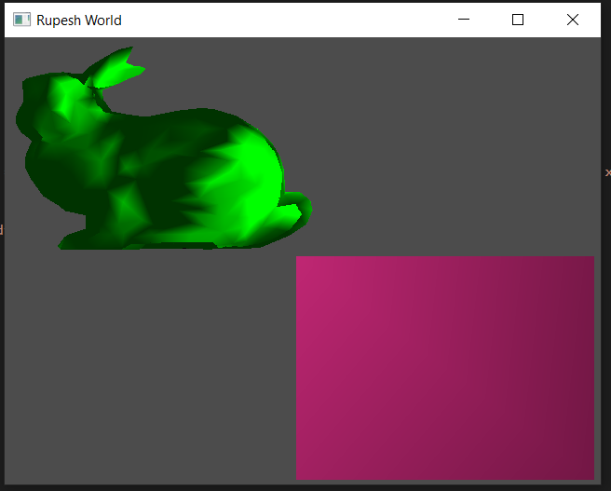

**I press, 3 press and bumpy cube is drawn**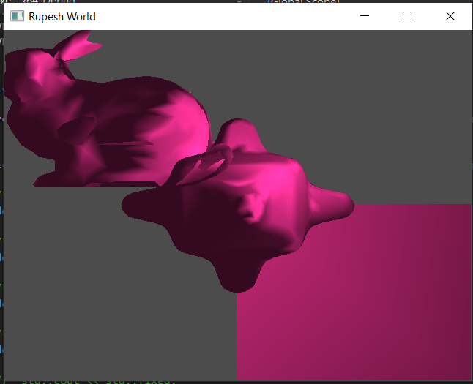

**Similarly translate bumpy cube**

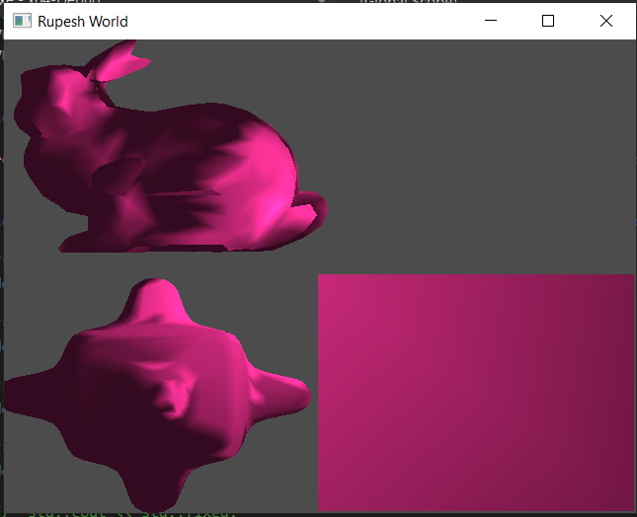

**Object Control and Shading**

**Press O select cube and Press L. Cube is scaled down.**

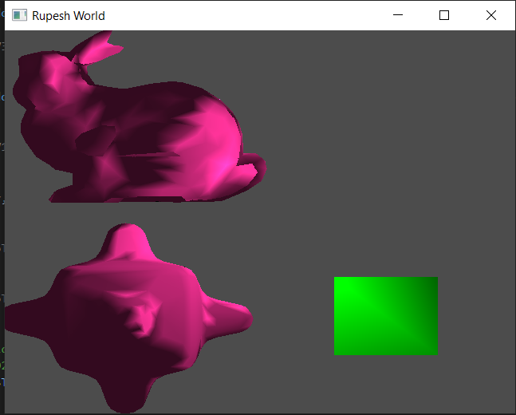

**Similary select bumpy cube press h it will rotate counter clockwise, select bunny translate and then press k it will scale up and then press j it will rotate clockwise**

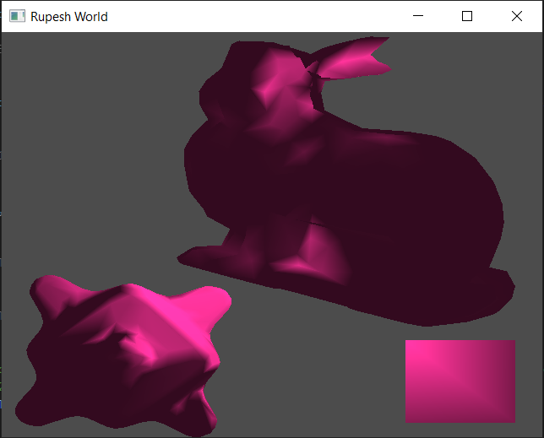

**Now delete previous objects and draw four bunny and translate**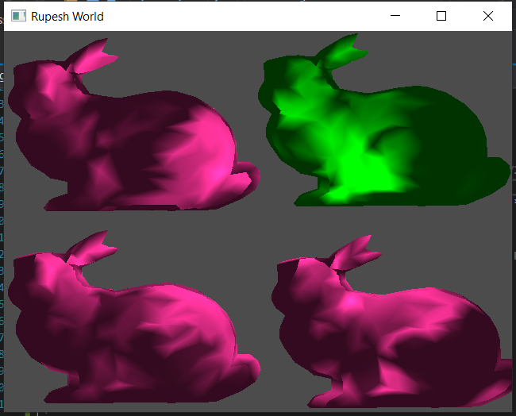

**Press x for perspective projection and press q twice so camera moves backward so the objects fit in screen. Carry different operations 1 bunny rotate counter clockwise, 2 bunny rotate clockwise, 3 bunny scaled up, 4 bunny scaled down** 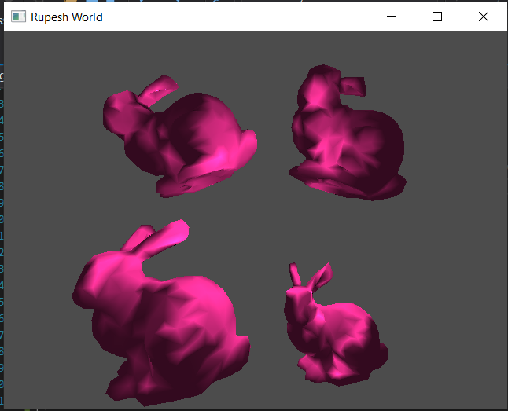

**Delete one of the bunny**

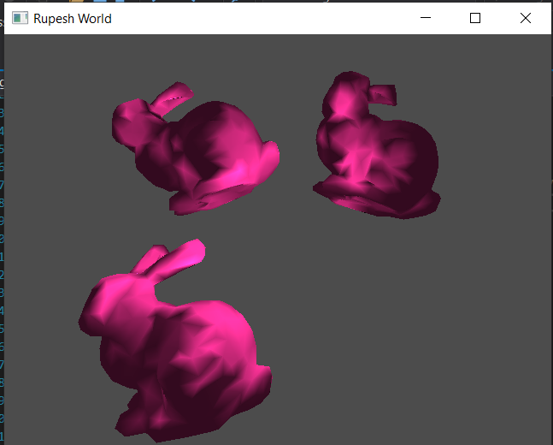

**revert them to orthographic projection press z**

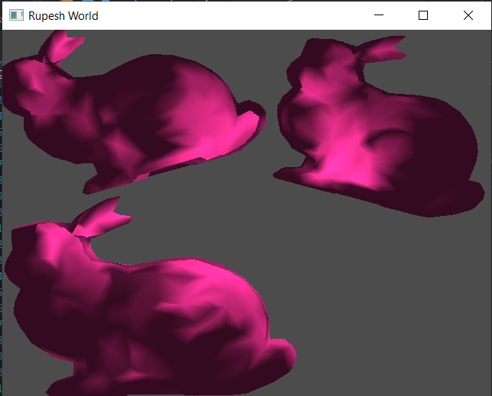

**Select 1st bunny press r for wireframe, select 2nd bunny press t for flat shading and 3rd bunny is phong shading**

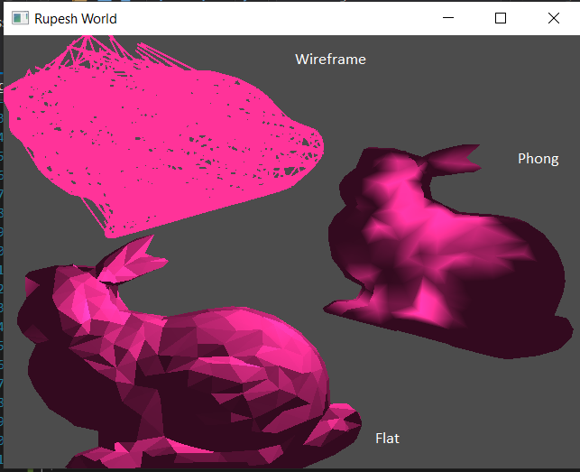

**Similarly in perspective projection**

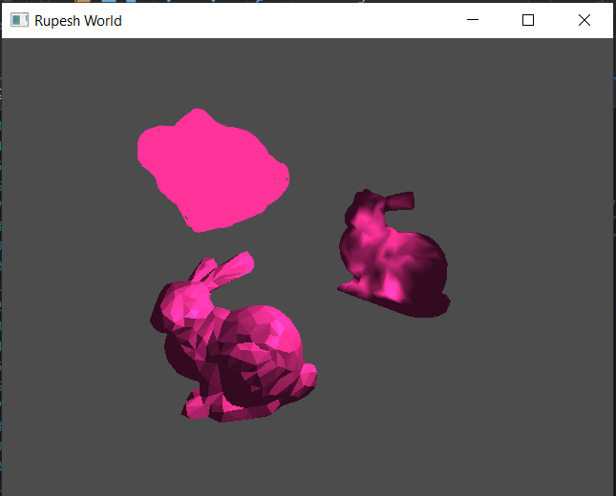

**For bumpyCube**

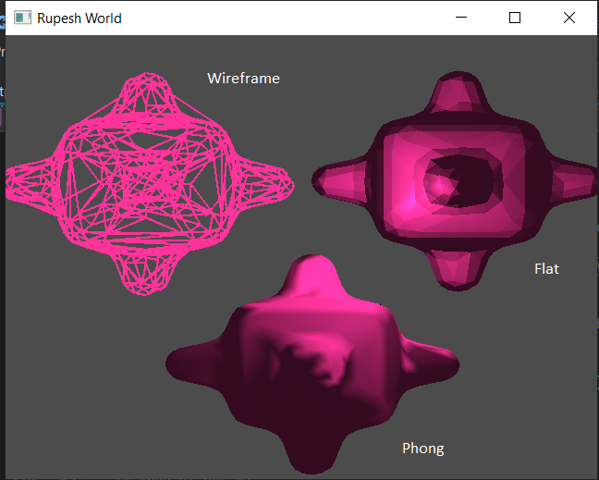

**For Cube**

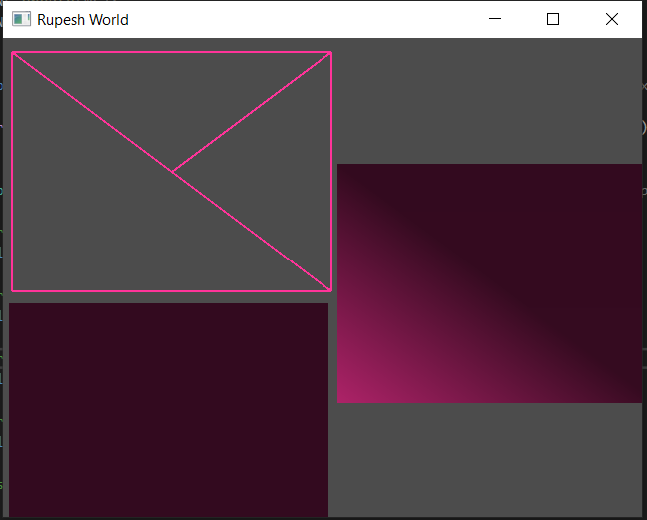

**Camera Control**

**Draw all 3 object and translate them Curremtly orthographic projection**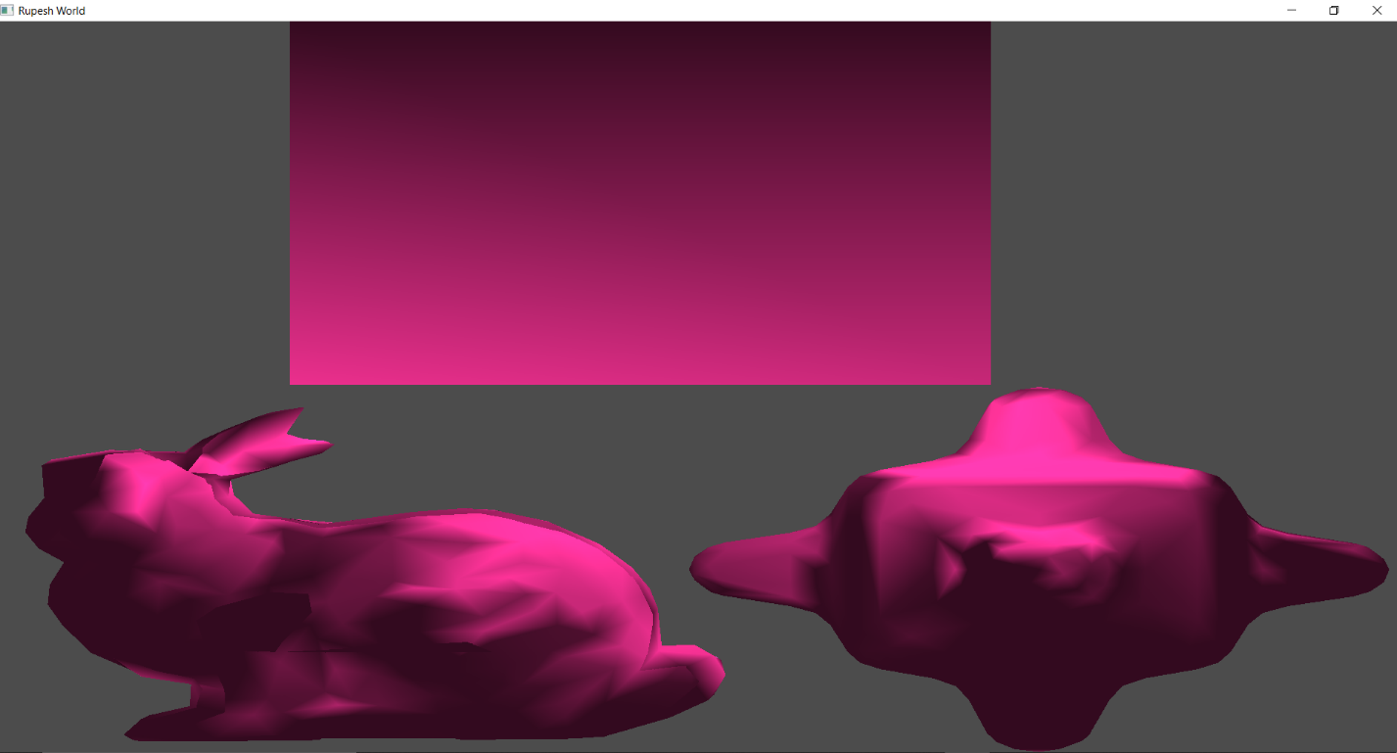

**Press d Move camera right**

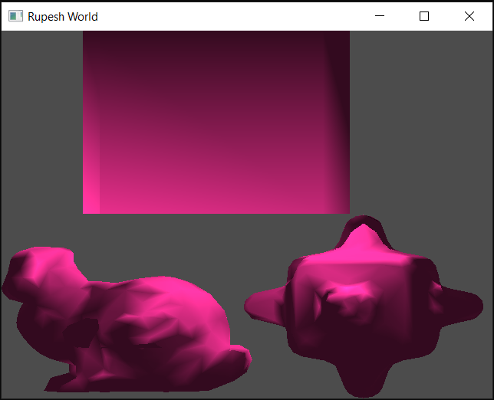

**Move more right by pressing d**

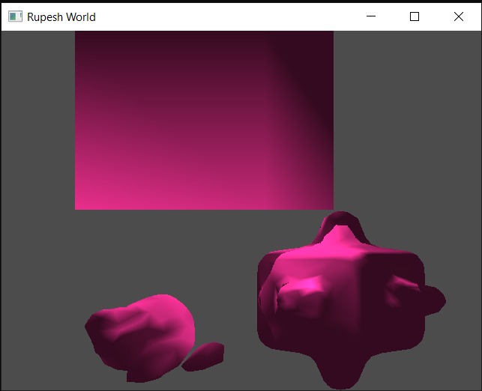

**Similary move camera left by pressing a**

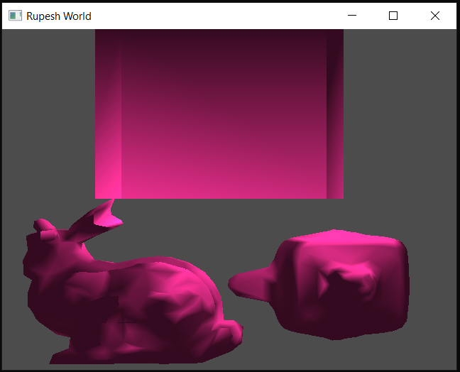

**More left**

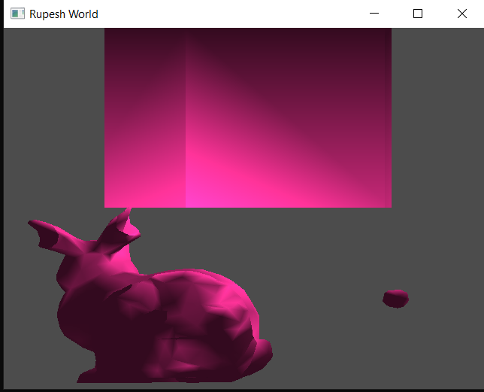

**Similarly move camera up by pressing w**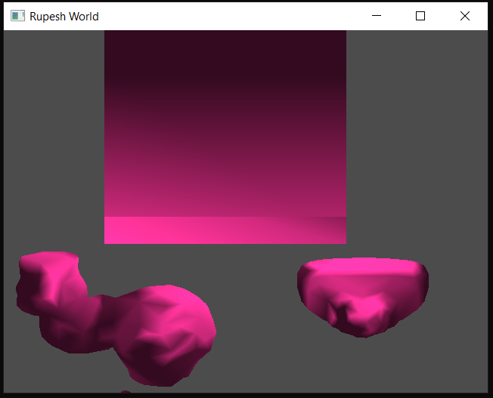

**Move camera down by pressing s**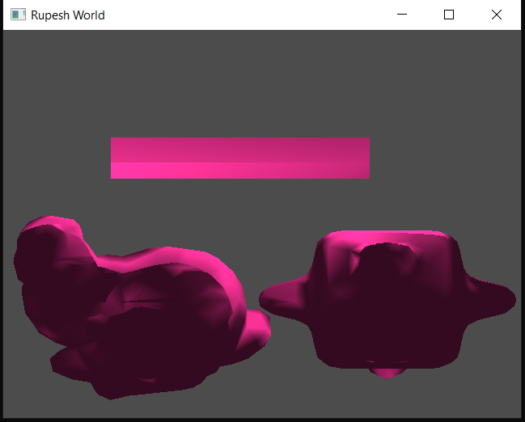

**Move camera forward by pressing e till it goes behind the object**

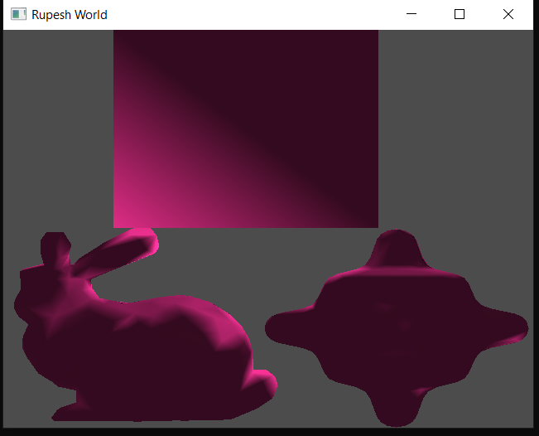

**Now perspective projection by pressing x**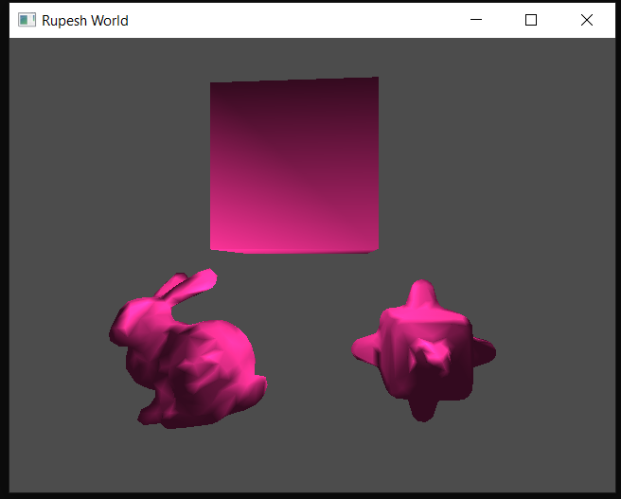

**Move left**

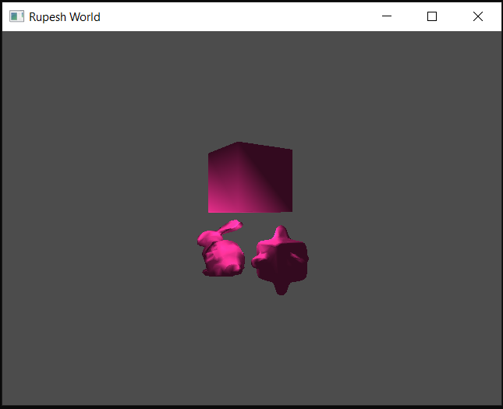

**Move right**

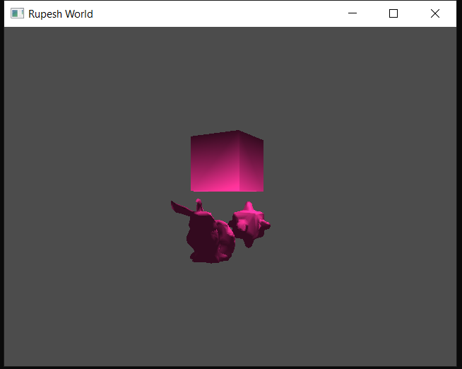

**Move down**

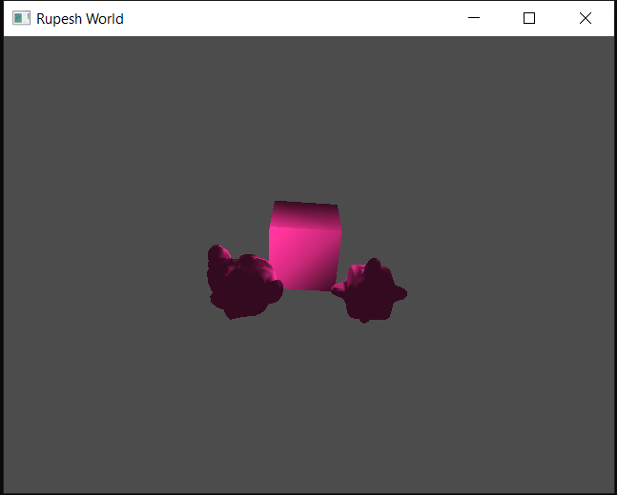

**Move up**

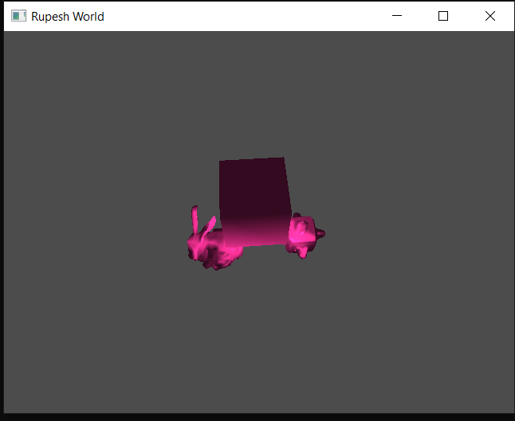

**Move camera back by pressing q**

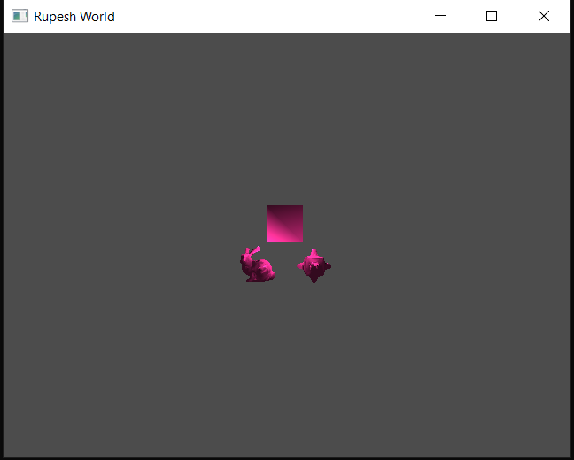

**Move camera forward by pressing e till it goes behind the object**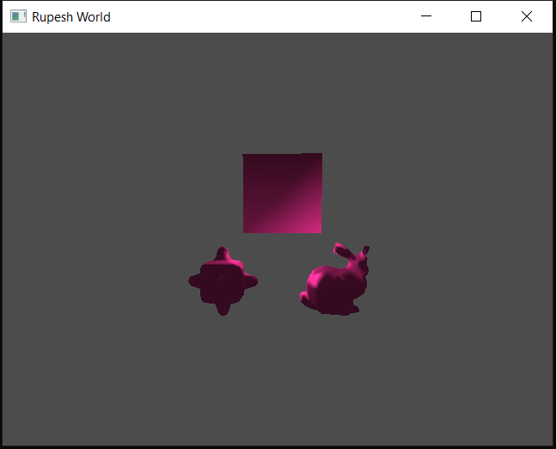

**Random camera position**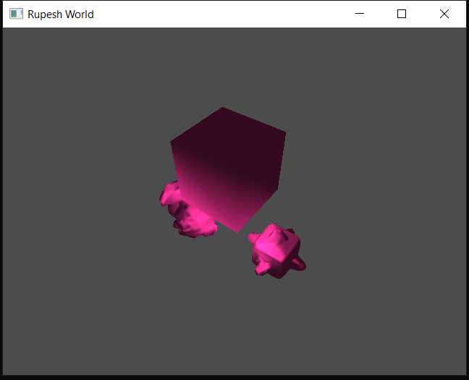

**Rotation translation scaling in perspective**

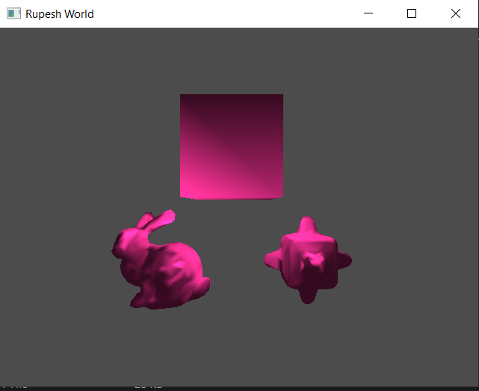

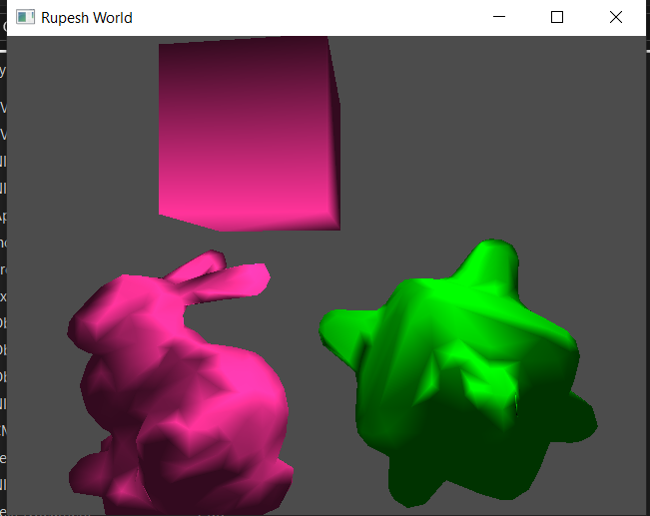

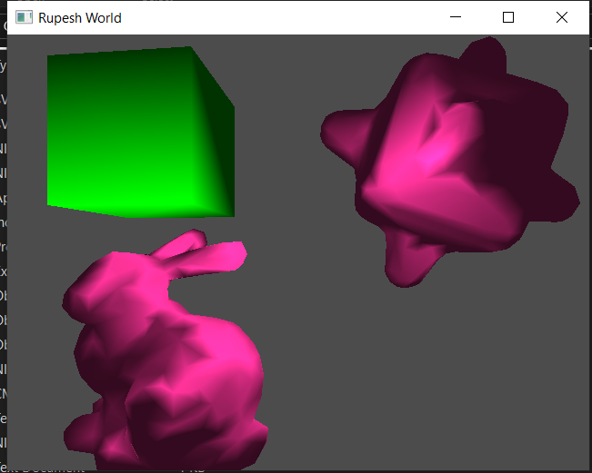

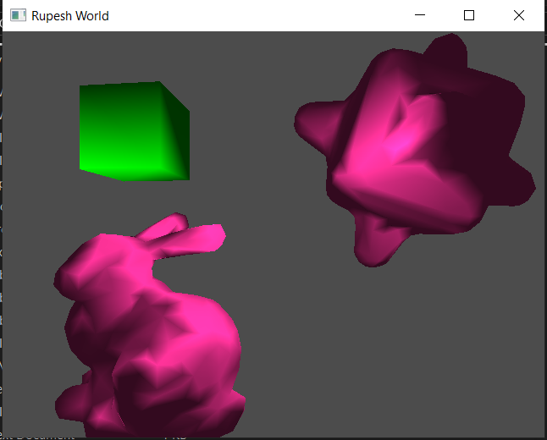

**Trackball**

**Press c so the camera enters in spherical mode and now control camera using the same buttons**

**GIF can be found beside ReadMe :- cam.gif, cam2.gif**





**Export in SVG**

**Press g the window is saved in output.svg format. The ‘output.svg’ file is compatible with inkscape. SVG can be found beside ReadMe: - Output1.svg, Output2.svg,**

**Orthographic**

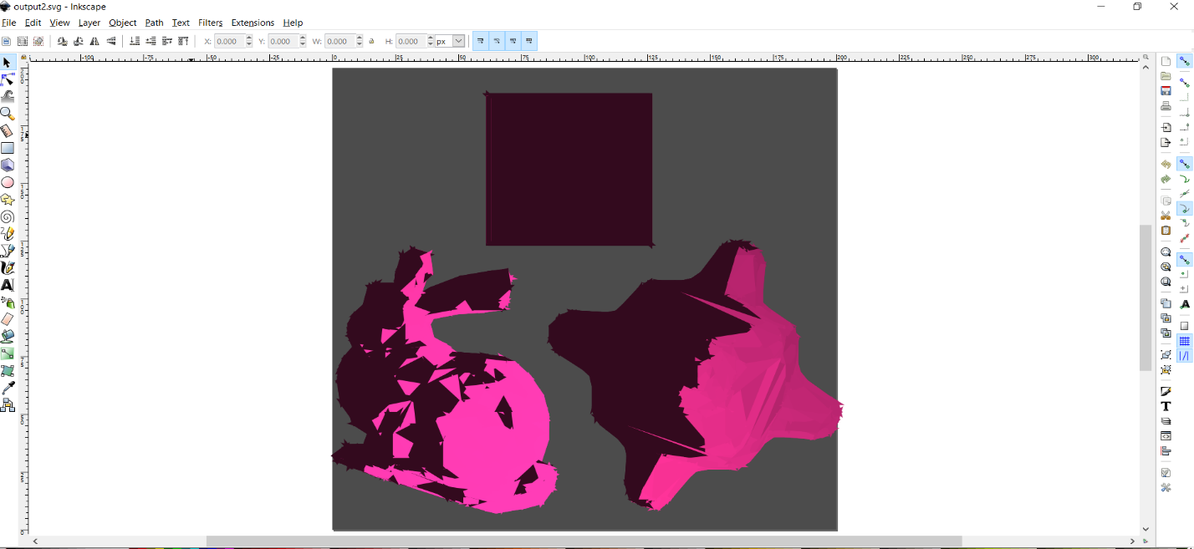

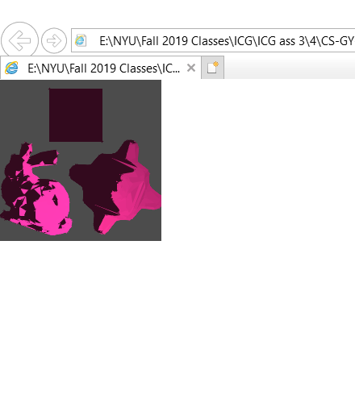

**For Perspective**

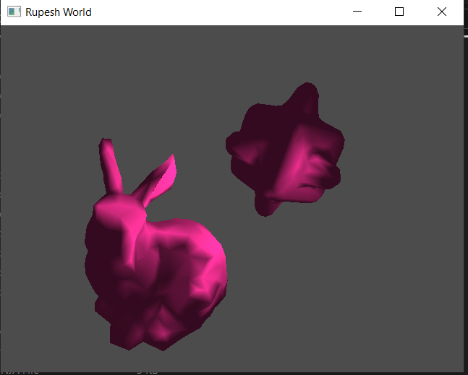

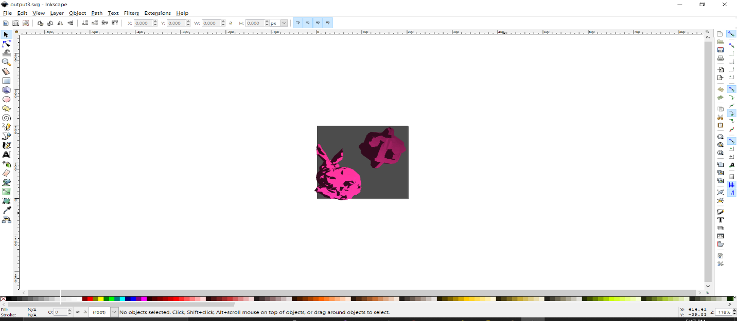

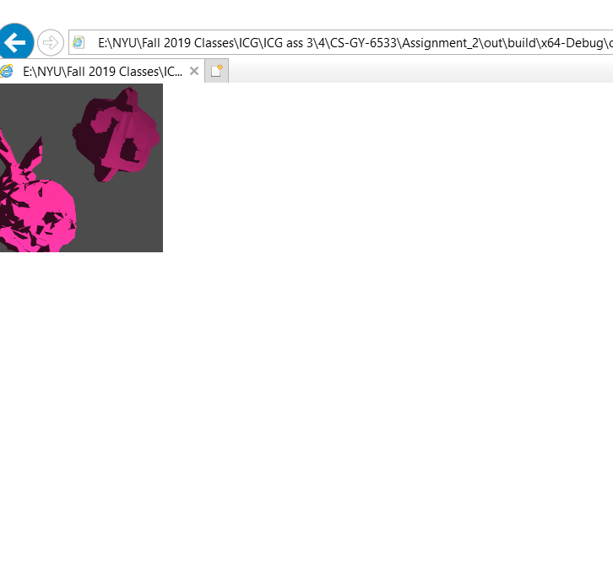

**Animation Mode**

**Press b the world will run in animation. Currently the Bezier curve is hardcoded with four points being (0,0),(0-1),(1,-1),(1,0). Thus making a U like curve. So the objected will be translated in U manner and will come back to original position when enter some other mode.**

**GIFs can be found beside ReadMe: - bco.gif, bcp.gif,**

**Orthographic**



**Perspective**

